1. AOI Cleanup
   * All good
2. Validity check
   * All good
3. Durations
   * Timestamp was overwritten, better to add an additional column if such a timestamp is needed
     1. Min function is also dangerous without checking if min is the first row value

df['Timestamp'] = (df['Timestamp'] - df['Timestamp'].min())  # set 1st timestamp to zero for readability

1. Data quality check
   * All but last row are handled well (due to usage of row shift, not defined in last row) – my approach: trust value and flag invalid just to be sure – 0 is definitely falsifying the data

Timestamp_duration = ((df['Timestamp']-(df['Timestamp'].shift()).fillna(0))/1000).round(0)  # create series of timestamp duration to compare and round to nearest integer

Timestamp_duration = Timestamp_duration.shift(periods=-1)  # shift series to match our data

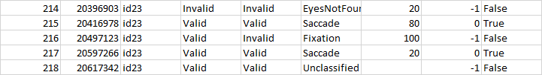

1. Reduction
   * Right idea, not finished
2. Recalculated durations
   * All good
3. Validity
   * Looks good, row percentage wrong due to missing merge
4. Export
   * All good